Quick Reference Guide to School Uniform The images below are intended as a guide. We do allow sweatshirts/cardigans with our school logo on and plain green ones. We also accept grey or black trousers/skirts/shorts.

UNIFORM | SUMMER | PE
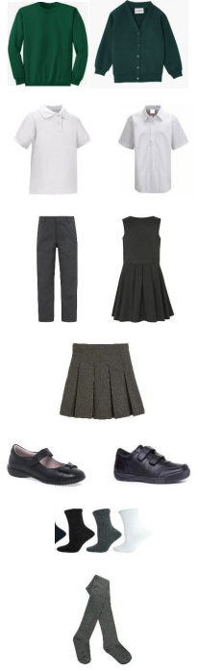 | 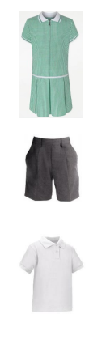 | Houses coloured T shirts allocated when they start 

